FEED1 – Fluids Exclusively Enteral from Day 1

Participant Information Sheet
Part A: Study Information
Version 2 14 May 2020
IRAS Project ID: 266702

You are invited to take part in our research study
- This information sheet is to make sure you understand why the research is being done and what it will involve for you and your baby/babies if you decide to take part.
- Please take time to read this information. Talk to others such as your family or your doctor if you wish and ask your local research team if you would like more information.
- It is entirely up to you whether you take part in this study. If you agree to take part, you are free to stop at any time without giving a reason. If you choose not to take part, your baby’s/babies’ care will continue in the normal way.
- Please ask us (the research team) if there is anything that is not clear or if you would like more information.

A summary of the study
- Babies who are born early are currently fed small amounts of milk through a tube into their stomach, with additional nutrition through a drip into their veins. We call this “gradual milk feeds” in this study.
- We want to know whether starting babies on “full milk feeds” rather than “gradual milk feeds” will lead to babies going home from hospital earlier.
- To help us understand more, we are comparing these two different ways of feeding babies:
(1) gradual milk feeds (usual care) and (2) full milk feeds
- We will collect data until your baby is discharged from hospital.
- We will send you a questionnaire to complete once your baby reaches 6 weeks corrected age (6 weeks after their due date).
- We may contact you again (with your permission) up until your baby turns 2 years of age to see how your baby is doing.
- If you take part in the study and have given birth to more than one baby, each baby will be fed in the same way, if they are eligible to join the study.

How to contact us
Contact details of your local care team
<INSERT CONTACT DETAILS HERE>

What is the purpose of the study?
Babies who are born early cannot feed for themselves and are given small amounts of milk through a tube into their stomach. They are also given additional nutrition through a drip into their veins (intravenously or IV). The milk is slowly increased until they are fully milk fed and no longer need any IV nutrients. We call this “gradual milk feeds”.

We feed premature babies like this because of concerns about a serious bowel disease called Necrotising Enterocolitis (NEC). However, research suggests that for premature babies who aren’t too poorly, larger milk feeds can be given without increasing the risk of NEC, and might also reduce the risk of severe infection.

In this study we want to find out whether babies born 8-10 weeks early will do better if we feed them fully with milk from the first day. We want to know whether this will help babies go home sooner (reduce the number of days they need to stay in hospital). We will also check if this helps reduce infection risks, affects the risk of NEC, and helps mothers breast feed and be more involved in caring for their baby.

The study is taking place in neonatal units across the UK and we want to include 2088 babies in it.

Why have I been invited?
You have been invited to take part in this study as you are either in preterm labour, have a planned delivery 8-10 weeks early, or your baby has been born 8-10 weeks early.

Do I have to take part?
It is up to you whether or not you join the study. We will talk to you about the study and answer any questions you may have. Your baby’s care will not be affected in any way if you decide you do not want your baby to take part. You are free to withdraw at any time, without giving a reason. This will not affect the standard of care you or your baby receive.

What would taking part involve?
If you have been approached to take part in this study before giving birth, we will ask you to sign a written consent form. If you then deliver 8-10 weeks early, you will participate in the study.

If you are about to or have just given birth, you will have already confirmed verbally that you wish to take part in the study, and you will be asked to sign a written consent form at a more practical time.

Soon after birth, if the team taking care of your baby thinks your baby is well enough to participate in the study, the decision to use full milk from day 1 or gradual milk feeds will be selected by a computer. The computer will decide randomly and you will have an equal chance of being in either of the two groups. If you have more than one baby from this pregnancy, all your babies will receive the same feeding method.

All other feeding decisions will still be made by the doctors and nurses caring for you baby and the rest of your baby’s care will follow your hospital’s usual practice.

What milk will my baby receive?
Whether or not you take part in the study, you will choose the type of milk your baby will be given after talking with the doctors and nurses. Your breast milk is the best milk for your baby. Your midwife, nurses, and doctors will support you to express milk for your baby. If you choose not to use expressed milk or if your milk takes time to come in for the first few days, the doctors and nurses will discuss other options (such as [human donor milk or] formula milk) that can also be used during the study.

The flowchart below shows what will happen if you decide to take part in the study.

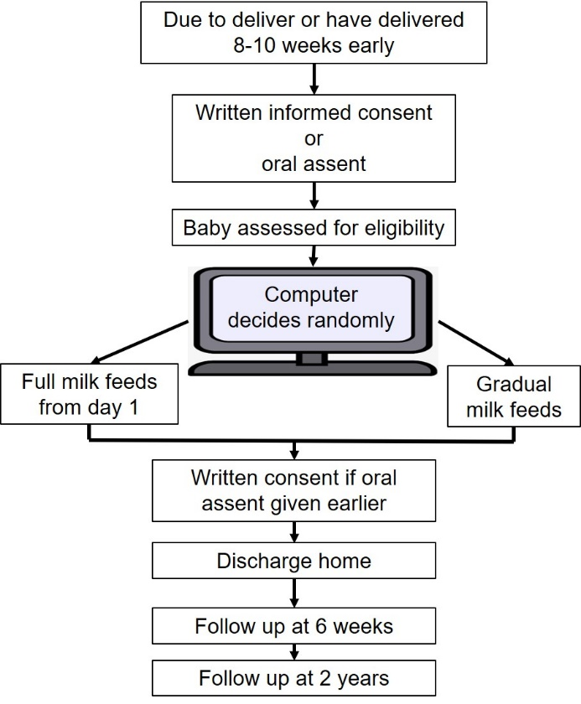

Data about how your baby’s health, such as how they feed and grow will be collected until your baby goes home.
We will send you a questionnaire (either online or in the post) to complete when your baby reaches 6 weeks corrected age.

With your permission, we would like to maintain contact with you as we want to find out how your baby is doing when they reach 2 years of age.

What are the possible benefits of taking part?
We do not know if taking part in the study will benefit you or your baby directly, but by doing this study we are hoping to find the best way of feeding preterm babies which may help to guide the care of premature babies in the future.

What are the possible disadvantages and risks of taking part?
If your baby is in the full milk group, they will be given milk from the first day. This amount of milk may be difficult for your baby to tolerate and they may vomit and/or develop bloating. If this happens the doctors and nurses caring for your baby will decide what is best for your baby and may give smaller amounts of milk more frequently or reduce the amount of milk. There may be benefits from full milk from day 1, such as reducing infections and the need for drips associated with IV feeding in the gradual milk group.

What if there is a problem?
All babies will be monitored extremely closely throughout the study by the hospital staff. If your baby is unwell or is struggling, the doctor will discuss this with you and do what is best for the baby’s care regardless of which group of the study your baby is in.

If you have concerns or questions about any aspect of this study, you should ask to speak to the local researchers. Their contact details are at the front of this sheet.
If any questions remain you can contact the study coordinating centre:

Feed1@nottingham.ac.uk
0115 82 31592

In the event that something does go wrong and you are harmed during the study, there are no special compensation arrangements. If you are harmed and this is due to someone’s negligence then you have grounds for a legal action for compensation but you may have to pay your legal costs. The normal NHS complaints mechanism will still be available to you.

If are unhappy or wish to complain formally, you can do this through the NHS Complaints Procedure via the Patient Advisory and Liaison Service (PALS)

<insert Local PALS details>.

What will happen if I don’t want to carry on with the study?
You are free to withdraw at any time, without giving any reason, and without your legal rights being affected. If you withdraw then the information collected will not be erased and this information may still be used in the project analysis.

What will happen to the results of the research study?
We plan to publish the results of this study in a scientific journal and may also present the results at relevant conferences. You will not be identified in any publication. We will also send you a summary of the study results, unless you ask us not to.

Who is organising and funding this study?
Derby and Burton Hospitals NHS Foundation Trust are the sponsor of this study. The study is funded by the research arm of the NHS, the National Institute for Health Research Health Technology Assessment (NIHR HTA) Programme and coordinated by the Nottingham Clinical Trials Unit.

How have patients and the public been involved in this study?
The method of feeding preterm babies was outlined as one of the priority areas of research into babies born prematurely by a group of parents of preterm babies. Bliss, the UK’s leading charity for babies born premature or sick, are active partners in our study. Parents of preterm babies have helped to design the study and have reviewed the study documents.

Who has reviewed the study?
All research in the NHS is reviewed and approved by an independent group of people, called a Research Ethics Committee, to protect your interests. This study has been reviewed and approved by East Midlands Derby Research Ethics Committee.

What if relevant new information becomes available?
If we get new information about the feeding of preterm babies during the study, your research doctor will tell you and discuss whether you should continue in the study. If you decide not to carry on, your research doctor will make arrangements for your care to continue as normal. If you decide to continue in the study they may ask you to sign a new Informed Consent Form.

What happens when the research stops?
When the study ends, your baby will continue to be cared for by their care team. If you withdraw from the study, we will need to keep and use the data collected up to your withdrawal.

Thank you for reading, you will be given a copy of this Participant Information Sheet to keep. Please see Part B for information regarding Data Protection and Confidentiality.

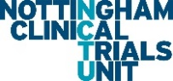
[Insert local Trust logo]

FEED1 – Fluids Exclusively Enteral from Day 1

Participant Information Sheet
Part B: Data Protection and Confidentiality

How will we use information about you?
We will need to use the information from you and your baby/babies medical records for this research project. This information will include your initials, yours and your baby’s names and NHS numbers and your contact information. People will use this information to do the research or to check yours and your baby’s records to make sure that the research is being done properly.

People who do not need to know who you are will not be able to see your name or contact details. A copy of your consent form will be sent to the Nottingham Clinical Trials Unit (NCTU) but any other information about you which leaves the clinic will be anonymised, meaning your name and address will be removed. Your data will be anonymised with only your initials and Date of Birth and you will be identified by a code number instead. No one will be able to identify your involvement when the findings are published at the end of the study. The anonymised information collected about you may be used to support other research in the future and may be shared with other researchers.

Your personal contact details will be available to the NCTU so they can contact you during the study and send the questionnaires, they may also contact you to discuss the questionnaire if necessary. Once the study is finished, some of the data will be kept so we can check the results. Your name and email address will be kept after the end of the study so that we can contact you about the findings of the study. If you do not wish to be contacted with the results of the study your name and email address will be disposed of securely at the end of the study. All other data (research data) will be kept securely for 5 years. After this time, your data will be disposed of securely.

We will keep all information about you safe and secure.

What are your choices about how your information is used?
You can stop being a part of the study at any time, without giving a reason, but we will keep the information about you that we already have.

- If you choose to stop taking part in the study, we would like to continue collecting information about your baby by sending you the follow-up questionnaire. If you do not want this to happen, tell us and we will stop.

- We need to manage your records in specific ways for the research to be reliable. This means that we won’t be able to let you see or change the data we hold about you.

Where can you find out more about how your information is being used?
You can find out more about how we use your information:
- At www.hra.nhs.uk/information-about-patients/

- At https://www.uhdb.nhs.uk/research-how-we-use-your-information

- By sending an email to feed1@nottingham.ac.uk

